**Wind Energy Conversion Systems**

**Assignment 5**

**M.Shamaas**

**ID # 2018-MS-EE-4**

**Introduction**

This case study investigates the operation of the grid-tied two level inverter with Voltage Oriented Control and Reactive Power Control. The 2.3MW/690V grid-connected inverter is controlled by the VOC scheme with a decoupled PI controller and Space Vector Modulation.

The αβ stationary reference frame is derived from abc- space vectors by putting θ = 0 and . The transformation of three-phase variables, in the stationary reference frame into the two-phase variables, also in the stationary frame is often referred to as abc/αβ transformation:

Similarly, the two-phase to three-phase transformation in the stationary reference frame, known as αβ/abc transformation, can be performed by:

The dq-axis synchronous reference frame variables can be obtained from abc-vectors by decomposing the voltage and current space-vectors into their corresponding d- and q-axis components.

where is the angle between a- and d- axis.

The grid synchronous reference frame is derived from abc-axis stationary reference frame by putting θ = :

Similarly, the two-phase to three-phase transformation in the stationary reference frame, known as dq/abc transformation, can be performed by:

where the grid phase a voltage angle is given by:

so that the grid voltage space vector is coincident with d- axis and rotates at a speed of:

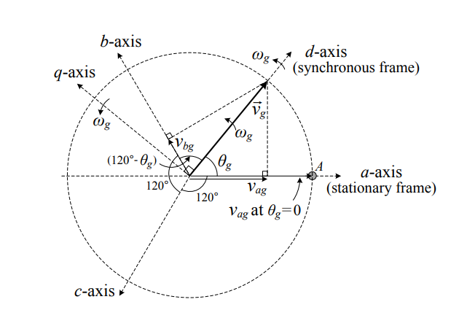

**Operation of Voltage Source Converter**

A three-phase two-level voltage source converter is composed of six switches with an anti-parallel free-wheeling diode with each switch. It converts a fixed dc voltage to a three-phase ac voltage with variable magnitude and frequency for an ac load or grid connection. The power flow in the converter circuit is bidirectional: the power can flow from its dc side to the ac side, and vice versa. It delivers the power generated from the generator to the grid. The grid-connected or grid-tied inverter normally delivers power from its dc side to the ac side.

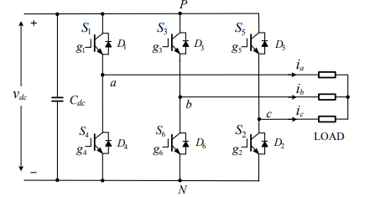

Space vector modulation (SVM) is a real-time modulation technique widely used for digital control of voltage source inverters. The operating status of the switches in the two-level inverter can be represented by switching states. The switching state ‘P’ denotes that the upper switch in an inverter leg is on and the inverter terminal voltage is positive (+Vdc) while ‘O’ indicates that the inverter terminal voltage is zero due to the conduction of the lower switch. There are eight possible combinations of switching states in the two-level inverter. Among the eight switching states, [PPP] and [OOO] are zero states and the others are active states.

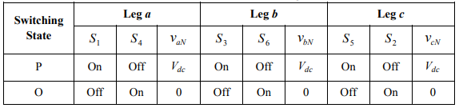

The active and zero switching states can be represented by active and zero space vectors, respectively in the αβ reference frame. The space vector diagram below represents the six active vectors which form a regular hexagon with six equal sectors (I to VI). The zero vector V0 lies on the center of the hexagon.

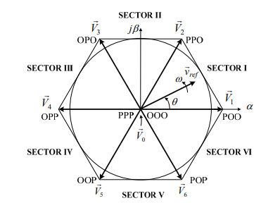

where k represents the sector.

For a given magnitude and position, can be synthesized by three nearby stationary vectors (OOO, POO and PPO in sector 1), based on which the switching states of the inverter can be selected, and gate signals for the active switches can be generated. When passes through sectors one by one, different sets of switches will be turned on or off. As a result, when rotates one revolution in space, the inverter output voltage varies one cycle over time.

The inverter output frequency corresponds to the rotating speed of while its output voltage can be adjusted by the modulation index:

The dwell time for the stationary vectors represents the duty-cycle time of the chosen switches during a sampling period Ts. The dwell time calculation is based on ‘volt-second balancing’ principle, that is, the product of the reference voltage and sampling period Ts equals the sum of the voltage multiplied by the time interval of chosen space vectors. Assuming that the sampling period Ts is sufficiently small, the reference vector ref v r can be considered constant during Ts. Under this assumption, can be approximated by two adjacent active vectors and one zero vector. Ta , Tb and T0 are the dwell times for the vectors , and , respectively:

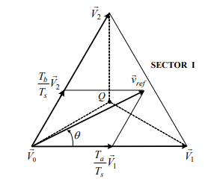

When is in other sectors, a multiple of π 3/ is subtracted from the actual angular displacement θ such that the modified angle θ ′ falls into the range between zero and π 3/ for use in the equation, that is,

for 0 ≤ θ′ <

where k = 1, 2, …6 for sectors I, II, …, VI, respectively. For example, when is in sector II, the calculated dwell times Ta, Tb and T0 are for vectors , and respectively.

With the space vectors selected and their dwell times calculated, the next step is to arrange switching sequence. In general, the switching sequence design for a given is not unique, but it should satisfy the following two requirements for the minimization of the device switching frequency:

a) The transition from one switching state to the next involves only two switches in the same inverter leg, one being switched on and the other switched off;

b) The transition for ref v r moving from one sector in the space vector diagram to the next requires no or minimum number of switching.

The optimized seven segment switching sequence is given in the table below.

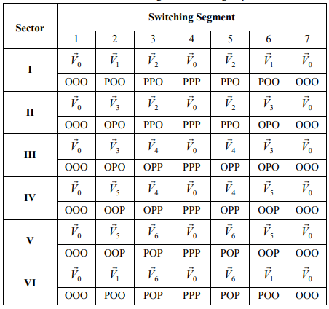

The overall Space Vector Modulation block diagram is given below.

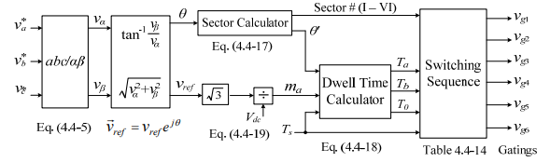

**Stator Voltage Oriented Control of Doubly Fed Induction Generator WECS**

In DFIG wind energy systems, the stator of the generator is directly connected to the grid, and its voltage and frequency can be considered constant under the normal operating conditions. It is, therefore, convenient to use stator voltage oriented control (SVOC) for the DFIG. This is in contrast to electric motor drives, where rotor- or stator-flux field oriented controls (FOC) are normally used. The stator voltage oriented control is achieved by aligning the d-axis of the synchronous reference frame with the stator voltage vector vs. The resultant d- and q-axis stator voltages are

= 0 and =

where vs is the magnitude of v, (also the peak value of the three-phase stator voltage). The rotating speed of the synchronous reference frame is given by

where fs is the stator frequency of the generator (also the frequency of the grid voltage). The stator voltage vector angle is referenced to the stator frame, which varies from zero to 2π when vs rotates one revolution in space. The rotor rotates at speed . The rotor position angle is also referenced to the stator frame. The angle between the stator voltage vector and the rotor is the slip angle, defined by

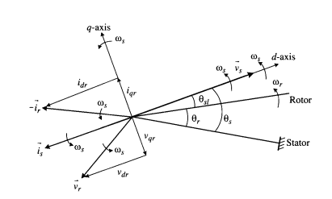

Since the DFIG operates with unity power factor, the stator current vector is is aligned with vs but with opposite direction (DFIG in generating mode). The rotor voltage and current vectors, vs and is, which are controlled by the converters in the rotor circuit, are also given in the diagram. The rotor voltage and current vectors can be resolved into two components along the dq axes: vdr and vqr for vr and idr and iqr for ir. These dq-axis components can be controlled independently by the rotor converters. The DFIG wind energy system can be controlled by the electromagnetic torque for speed control or active power. In contrast to the other wind energy systems, the electromagnetic torque Te of the generator, the active power Ps and the reactive power Qs of the stator are controlled by the rotor-side converter. Therefore, it is worthwhile to investigate the controllability of Te, Ps, and Qs by the rotor voltage and current. The investigation will also facilitate the analysis of the stator voltage oriented control. The electromagnetic torque of the generator can be expressed as

The stator active and reactive power can be calculated by

Neglecting the stator resistance Rs, we have

The stator voltage vector angle is identified by the calculator, and the rotor position angle is measured by an encoder mounted on the shaft of the generator. The slip angle for the reference frame transformation is obtained by = - . The abc/dq and dq/abc transformation blocks transform the variables in the abc stationary reference frame to the dq synchronous reference frame, and vice versa. The angle of the stator voltage vector can be obtained by

in which the dq-axis stator voltages are given by

The MPPT block generates the reference torque Te* based on the optimal torque method for maximum power point tracking. The reference dq-axis currents, idr* and iqr*, are compared to the measured values, idr and iqr, and the errors passed through PI controllers. The output of the PI controllers, vdr* and vqr* are the dq-axis rotor voltage references in the synchronous frame, which are transformed into a three-phase reference for rotor voltages, var*, vbr* and vcr* in the stationary frame. The rotor reference voltages can serve as the three-phase modulating waveforms in carrier-based modulation schemes or be converted into a reference space vector for the space vector modulation (SVM). The PWM block generates gating signals for the rotor-side converter. The grid-side converter keeps the DC link voltage vdc constant, and provides reactive power to the grid when required. The reactive power reference, QGSC* can be set to zero for unity power factor operation of the converter. The overall power factor of the DFIG wind energy system is then controlled by the rotor-side converter through its reference Qs*.

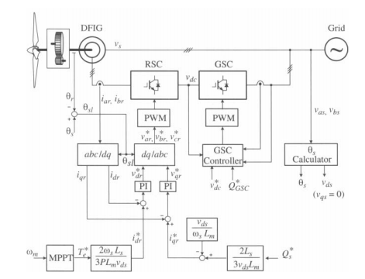

**Part1: Transients from Super-Synchronous to Sub-Synchronous Operation.**

The transients of a 1.5 MW/690 V DFIG wind energy system caused by a step change in wind speed are investigated. With the implementation of the MPPT scheme, the electromagnetic torque Te of the generator is proportional to the square of the rotor speed, whereas the mechanical power Pm is proportional to the cube of the rotor speed wm3. It is noted that the turbine speed is equal to the rotor mechanical speed in per unit terms and, therefore, there is no need to consider the gear ratio of the gearbox. The system initially operates in the super-synchronous mode with a rated rotor speed of 1.0 pu (1750 rpm). The case study investigates the transition when the wind speed suddenly decreases to 0.7 pu. At this point, the generator operates at the subsynchronous speed of 1225 rpm. With the rotational losses neglected, the mechanical torque of the generator Tm is equal to the mechanical torque generated by the turbine in per-unit terms. Initially, the wind energy system operates in steady state at 1.0 pu rotor speed, and the mechanical torque Tm from the turbine shaft is -1.0 pu. The electromagnetic torque of the generator Te is equal to the mechanical torque. It is noted that in the simulation, an ideal transformer with a turns ratio of 0.358 is added in the rotor circuit to match the rotor-side voltage with the grid voltage. Then, the wind speed suddenly decreases to 0.7 pu. The turbine mechanical torque Tm is instantly decreased from -1.0 pu to about -0.22 pu. However, the mechanical speed of the turbine and generator cannot change instantaneously due to the moment of inertia. The generator is in transition from the super-synchronous mode to sub-synchronous mode. The system finally reaches its steady-state operating point.

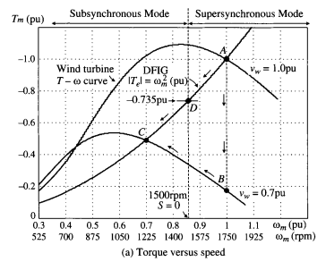

DFIG WECS Constants

1. Rated Power
2. Line-Line Voltage
3. Rated Stator Frequency
4. Rated Rotor Speed
5. Number of Pole Pairs
6. Rated Mechanical Torque
7. Stator Winding Resistance
8. Rotor Winding Resistance
9. Stator Leakage Inductance
10. Rotor Leakage Inductance
11. Magnetizing Inductance
12. Moment of Inertia

System Input Variables

1. Reactive Power reference
2. Grid Converter Reactive Power reference
3. DC Link Voltage Reference
4. Switching Frequency
5. DC Link Capacitor
6. Grid Voltage
7. Line Inductance

Steady State Values

|  |  |  |
| --- | --- | --- |
|  |  | |
| 1750 rpm (1.0 p.u.) | 1225 rpm (1.0 p.u.) |
|  | -8185 Nm (1.0 p.u.) | -4010.7 Nm (0.49 p.u.) |
|  | -1068.2 A (0.8510 p.u.) | -525.3 A (0.4185 p.u.) |
|  | 405.2 < 8.03° V | 400.7 < 4.0° V |
|  | 235.4 < -81.97° A | 589.3 < 156.8° A |
|  | 67.97 < -164.9° V | 76.99 < 6.5° V |
| s | -0.1667 | 0.1833 |
|  | -52.36 rad/s | 57.58 rad/s |
|  | 1591 (1.27 p.u.) A | 833.25 (0.664 p.u.) A |
|  | 96.12 (0.241 p.u.) V | 108.9 (0.2733 p.u.) V |
|  | 27.1° | -150.3° |
|  | 0.0538 + j0.027515 Ω | -0.11351 – j0.06472 Ω |
|  | -1.5 MW | -514.5 kW |
|  | -204.3 kW | -118.24 kW |
|  | 9.985 kW | 2.74 kW |
|  | 9.07 kW | 2.19 kW |
|  | -1.277 MW | -627.81 kW |
|  | 1.48 MW | 509.6 kW |
|  | 1230 A (0.9872 p.u.) | 426.4 A (0.3397 p.u.) |
|  | -8185 Nm (1.0 p.u.) | -4010.7 Nm (0.49 p.u.) |

Simulink Model

The input variables of the model include the dq-axis stator voltages vds and vqs, rotor voltages vdr and vqr, the mechanical torque Tm, and the speed of the arbitrary reference frame w. The output variables are dq-axis stator currents, ids and iqs, the electromagnetic torque Te, and the mechanical speed wm of the generator.

1. Complete System Diagram

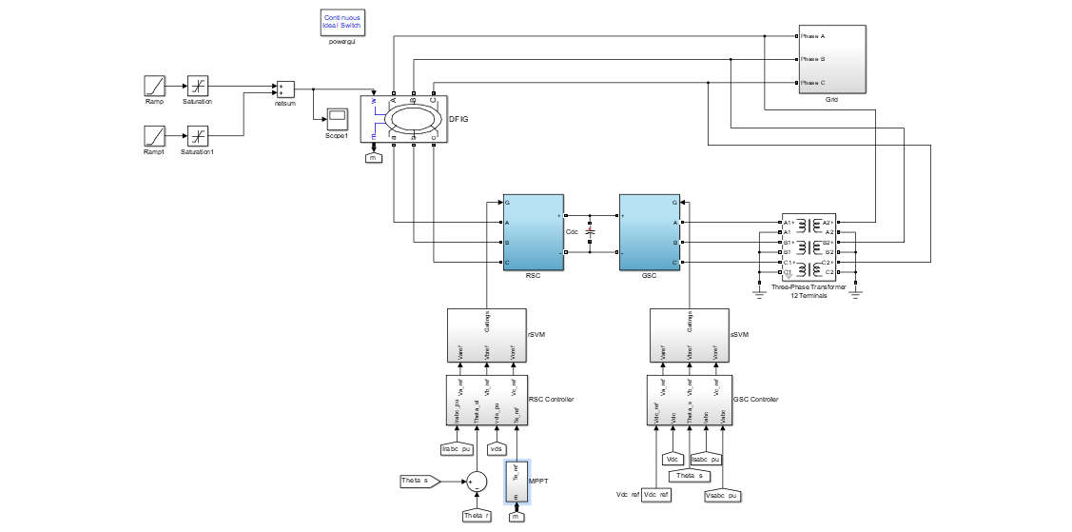

1. Rotor Side Converter Controller

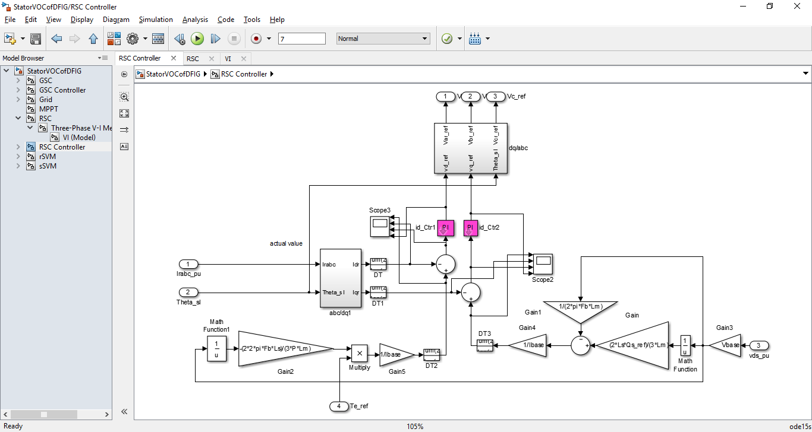

1. Grid Side Converter Controller

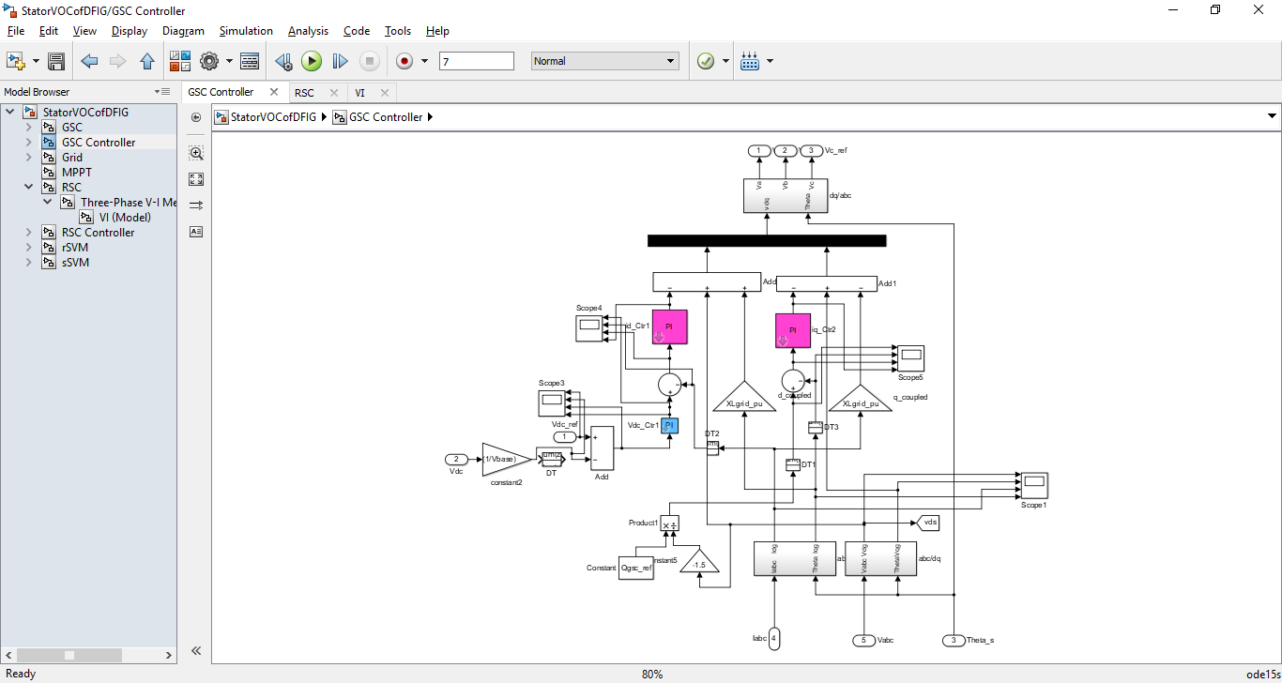

1. Rotor Side Converter

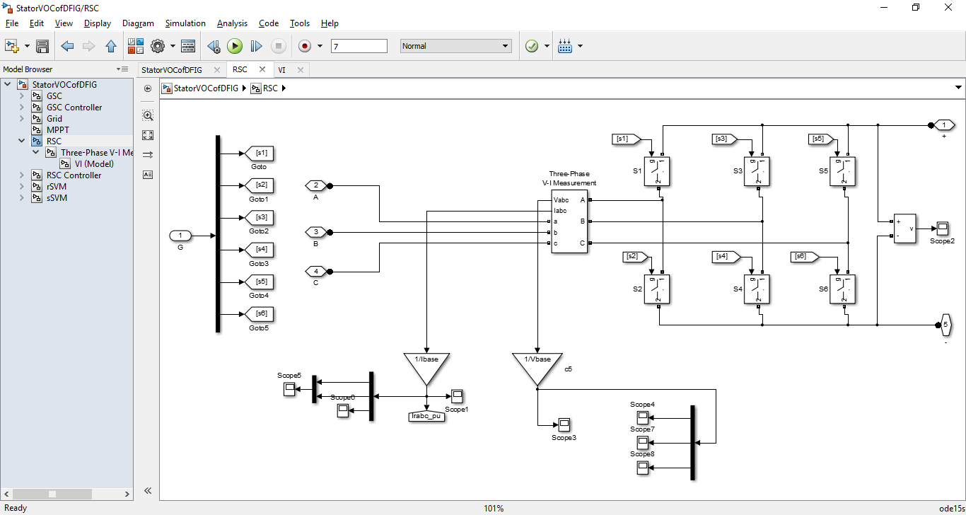

1. Grid Side Converter

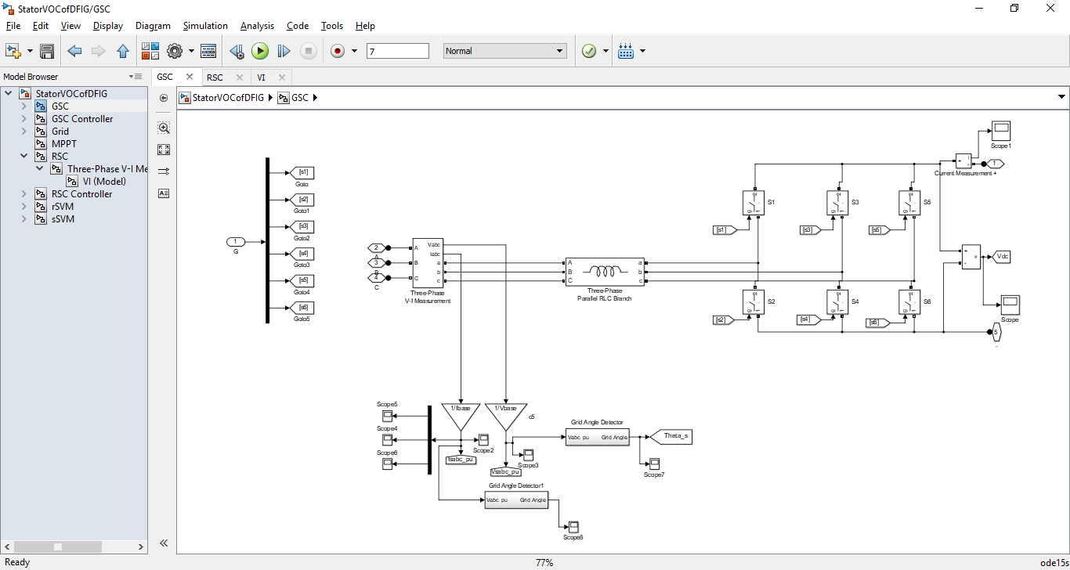

1. Grid System

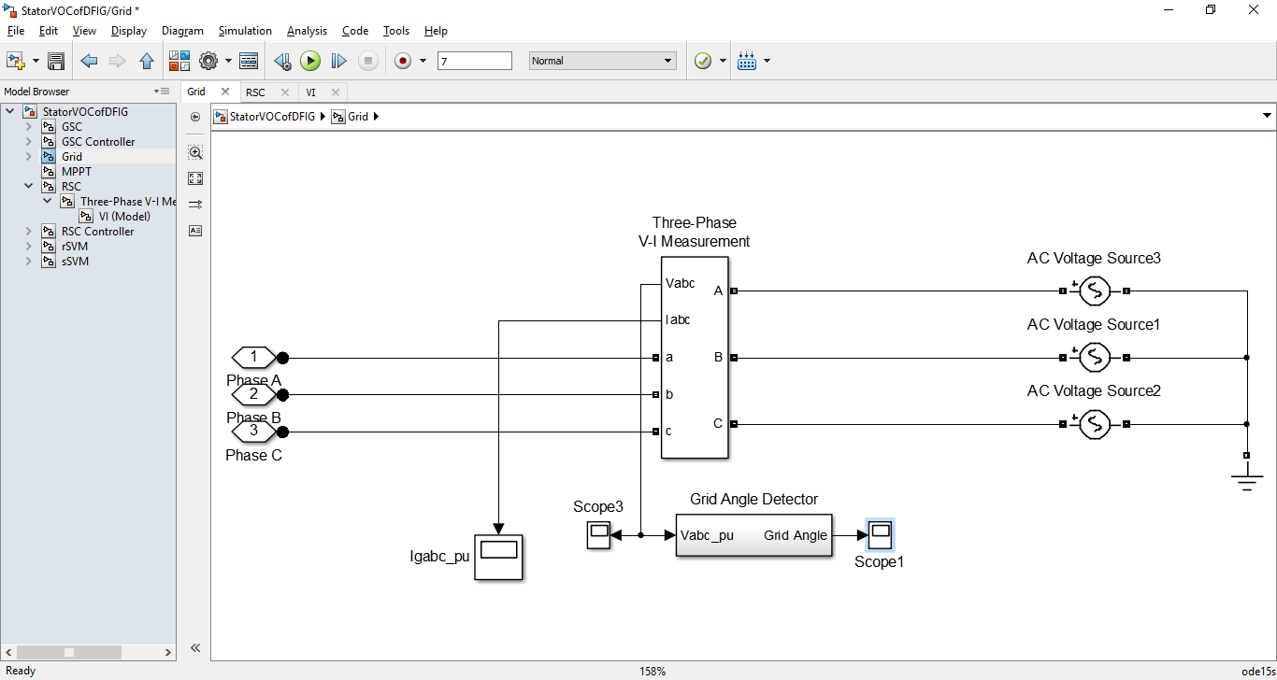

1. Maximum Power Point Tracking System and Measurement System

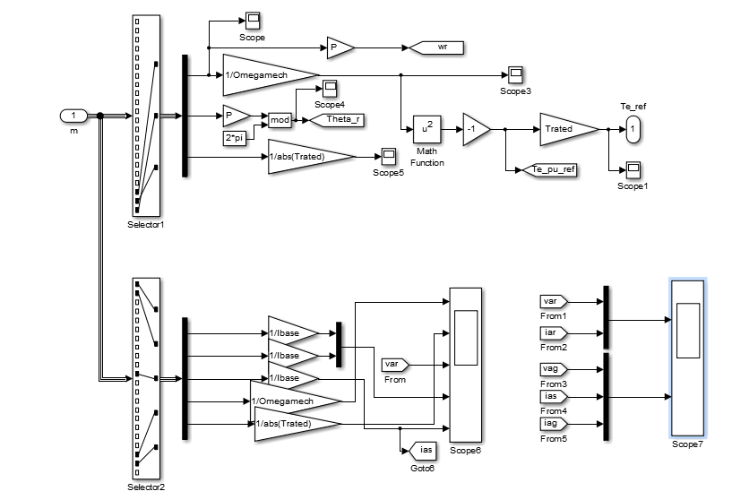

Simulation Results

1. Rotor Speed, Electromagnetic Torque, Var, Iar and Ibr, Ias

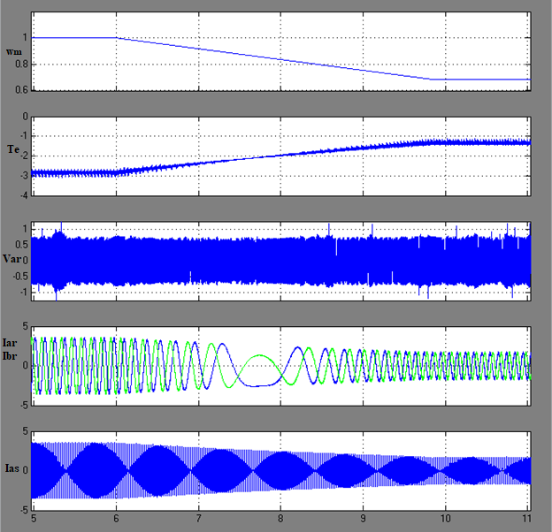

Initially the DFIG operates in steady state at 1750 rpm. It operates in super-synchronous mode with a slip of -0.1667. Its torque Te is negative so it is in generating mode.

Suddenly, the rotor speed starts decreasing. The DFIG enters synchronous mode with a slip of 0. It is still generating power with a negative Torque Te. The Rotor resistance and reactance falls to zero hence the rotor voltage falls. The slip speed was zero hence the frequency of rotor currents became zero. The stator currents also drop steadily.

Finally, the speed reaches 1225 rpm and the DFIG enters sub-synchronous mode. The slip is positive, but it was still delivering power to the grid. In steady state, the rotor and stator currents are much lower than before.

2. DC Link Voltage

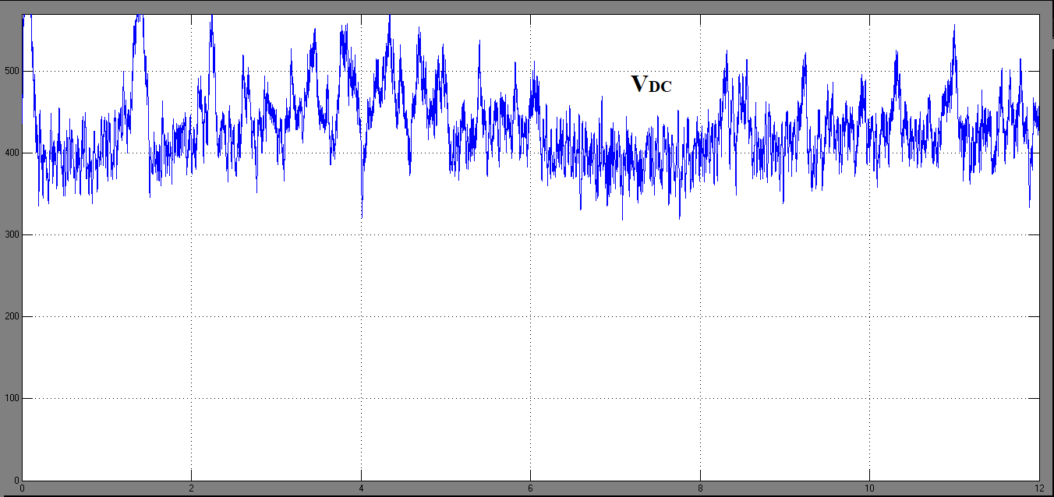

The GSC and RSC maintain the DC Link voltage at 436.2V.

1. Var and Iar; Vag, Iag and Ias.

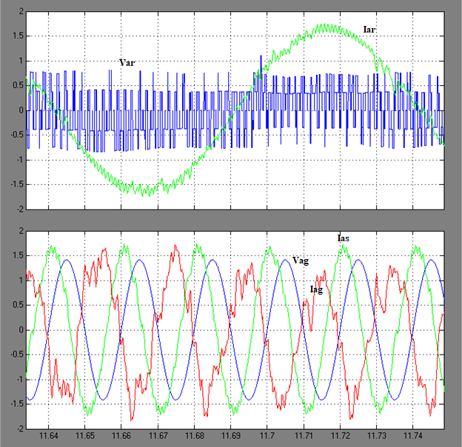

The steady-state waveforms of the DFIG WECS operating at 0.7 pu rotor speed show the phase-a rotor current iar and rotor voltage var. The waveforms of the grid voltage and current are 180 out of phase. The grid receives power at unity power factor.